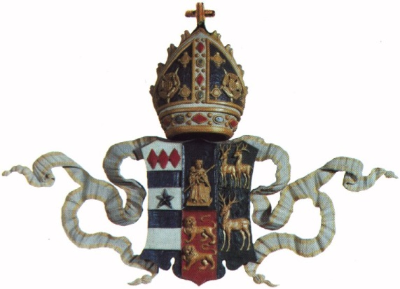
LINCOLN
COLLEGE
OXFORD

Rate Card for use of images
Fees for permission to use Lincoln copyright photographs and /or digital image(s) :

- Print books, periodicals
Rights Black & White Colour Notes
A. One country*, one language £20 £40 *EU=one country
B. One country*, all languages £30 £60 *EU=one country
C. World rights, one language £40 £80
D. World rights, all languages £80 £100

- Electronic books, periodicals, CD-ROM/DVDs: scale of use for a ten year term
Rights Colour Notes
A. One country*, one language £40 *EU=one country
B. One country*, all languages £60 *EU=one country
C. World rights, one language £80
D. World rights, all languages £100

- Book jackets, magazine covers, CD/Video covers
Rights Colour Notes
A. One country*, one language £100 *EU=one country
B. One country*, all languages £125 *EU=one country
C. World rights, one language £150
D. World rights, all languages £200

For other print use, such as greeting cards, posters and other commercial ventures, please ask.

- TV, Film, Video, App (up to 6 seconds)
Rights B & W/ Colour Notes
A. One programme, one transmission, £60 *EU=one country
one country*, one language
B. World rights, one language £150
C. World rights, all languages £200

- Electronic or online use (internet sites, apps etc.): scale of use for a ten year term
Rights B & W/ Colour Notes
A. One country*, one language £60 *EU=one country
B. World rights, one language £100
C. World rights, all languages £100

Current or former members of Lincoln College may be eligible for a reduction or a waiver of the fees, although a copy of the publication is required.
Similar arrangements may be possible for scholarly publications with small print runs.
Please provide further information in section 6 of the Permission to Use Images form, if you belong to either of these categories.
Additional charges may be payable for staff time, if appropriate.
Fees listed are exclusive of VAT, which is chargeable where appropriate; please provide relevant information for exemptions in section 6 of the Permission to Use Images form.

